Search Documentation of project

Alice in DaSCHland

Noémi Villars-Amberg

16.09.2025

Version 1.3

Copyright: DaSCH
License: CC BY 4.0
How to cite: Noémi Villars-Amberg, Search Documentation of project “Alice in DaSCHland”, 16.09.2025 (version 1.3)

Table of Content
Project Presentation 3
Purposes and goals 3
Key Features 3
Nature of gathered data 4
Type of data collected 4
Sources of the data 4
Privacy and Legal considerations 4
Data Processing 5

Fulltext Search

General
(https://docs.dasch.swiss/latest/DSP-APP/user-guide/data/search/#full-text-search)

DSP offers a full-text search that searches through all text values and labels of resources based on one or several terms (or phrase) entered in the search bar. It returns data that matches the search conditions.

Filter your full-text search by specific project
By default, the search is performed in all projects stored in DSP. However, it is possible to filter by project using the "Filter by project" menu on the left side of the search bar.

Search History
When clicking on the search bar, the search history panel is displayed. The last 10 searches are registered. Click on one search item to perform the same full-text search again. It is also possible to clear the search history list (“clear list” button at the bottom of the panel or the “x” at the end of each line).
Search history list is accessible for the full-text search from any webpage.

Search Rules
A search value must have a minimum length of 3 characters. If your search term has less than three characters (e.g. is), please add two asterisks (*is*).
All terms are interpreted as lowercase characters.
- E.g. My dearest Maria is interpreted as my dearest maria.
By default, the logical operator OR is used when submitting several search terms.
Each term separated by a whitespace is considered a single term.
- E.g. the expression Queen of Hearts is searched as queen OR hearts. The database will return all results that include the terms queen of hearts, queen, or hearts. In this case, the search results 169 resources.
- To find the exact expression Queen of Hearts, the term must be surrounded by quotes: "Queen of Hearts". The search results 10 resources.

Special Syntax
Special characters can be used in order to search for specific text patterns. Here is the list of characters with special meaning:
+, -, &&, ||, !, (, ), [, ], {, }, ^, ", ~, *, ?, :, \, /
For more information about them, please read the Lucene documentation:
https://lucene.apache.org/core/7_7_0/queryparser/org/apache/lucene/queryparser/classic/package-summary.html

Most common used characters
*: The askerisk can be used as a wildcard symbol for zero, one, or multiple characters.
- E.g. deco* will yield results such as decor, decoration, decorate, decorating, etc.
?: The question mark can be used as a wildcard symbol for a single character.
- E.g. Bern? will yield results such as Berne, Bernt, etc. (but not Bernasconi)
"": Quotation marks allow searches for the whole pattern.
- E.g. "White Rabbit" yields a result for the exact term White Rabbit. If your search term consists of more than one word and you intend to do an AND search, please use quotation marks.
In order to make searching easier and independent of special characters, we recommand to use the advanced search. It will narrow down the search and accept special letters or characters.

Include special characters in the search
If one of the above characters should be included in the search - without any special meaning - it needs to be escaped by the character \ .
- E.g. If you want to search for rock-cut, you should type rock\-cut.

Conversion
Alphabetic, numeric, symbolic, and diacritical Unicode characters which are not part of the first 127 ASCII characters (the "Basic Latin" Unicode block) are converted into their ASCII equivalents, if one exists. If this is not what you need, please use the advanced search option instead.
- E.g. é, ä, š are converted into e, a, and s. This means that a search for šumma will yield results for šumma, summa, ṣumma, śumma, etc.
For special characters that cannot be converted to ASCII equivalents, we suggest to replace the respective special character by an asterisk.
- E.g. r̥tasya, where the r̥ must be replaced either by rr or - simpler - by *: thus searches for rrtasya or *tasya will yield the intended search result, but not rtasya.

Advanced Search

General
The advanced search allows you to look for a specific term or expression present in one or multiple properties. The property can belong to one specific class or be used in multiple classes, according to the data model.
A query consists of the following elements:
- selection of a resource class belonging to the selected data model (optional)
- specification of properties, comparison operators, and values (optional)
Although the selection of a resource or a property or both are optional, either a resource class has to be selected or at least one property has to be specified, otherwise, the search button stays inactive.

Sorting
Once you determined the criteria for your search, you can open the "Order by" dropdown situated at the top of the form. By selecting the checkbox of the property, you specify what it will be sorted by.
The order of the entries determines which criterion should be used for sorting first. You can reorder them by clicking and dragging.
E.g: searching for Characters with a specific Keyword and sorting by the Keyword allows to sort by the subnodes of the Keyword you searched for.

Comparison Operators
Depending on the value type of the chosen property, one or more of the following comparison operators can be selected:

equals (value equality)
- exact same string
- same number
- an overlap of date periods
- same target resource
E.g.: looking for all Characters that have the Keyword "Fantasy" (list node) will result as all resources displaying the keyword “Fantasy”, including the sub-nodes "Imagination", "Surrealism", etc.

does not equal (value inequality)
- not exact same string
- not same number
- no overlap of date periods
- not same target resource
E.g.: looking for all Events that have a link to "Alice" but not to the "White Rabbit" results in a list of all Event Resources where Alice appear but not the White Rabbit.

exists
- value for the given property exists
E.g.: looking for all Book Chapters that have a “Chapter Number” will result in getting all chapters from the two stories, but not the prefaces or the poems.
Attention: looking for all Events (Adventure) for which the boolean property "Dangerous" was checked, will result 14 events, although not all of them are indeed dangerous. Here, 7 of the 14 events have the value set on FALSE, which is the reason why the search has a result. In order to get the resources that are "Dangerous", you must make a search with the operator "equals" and select "TRUE" from the list.

does not exists
- value for the given property doesn't exist
E.g.: the search for all Locations for which no Image exists will result in getting 8 resources.

is like (regular Expressions)
The operator lets the user search for texts that are like the search value via the support of regular expressions (SPARQL REGEX, more info via the link below)
E.g.: the search for all Labels that contains "Cheshire Cat" results 6 resources. In comparison, the search with the operator "equals" results only the one resource for which the Label is exactly "Cheshire Cat".

matches
- text property: search value matches the text (Lucene Query Parser Syntax).
- link property: matches the specified linked resource.
E.g.: looking for the term "Hatt*" results all finds that have the word "Hatter" or "Hatta" in the Label, which allows finding all data linked with the Mad Hatter, who is called differently in the two stories.

Greater/less than (value comparison)
- number is greater than search value
- date period begins after search value
E.g.: search for all Audio resources which size is bigger than 10Mb will result two resources.

Greater/less than or equal to (value equality/value comparison)
- number is equal to or greater than search value
- an overlap of date periods
- date period begins on or after search value.
E.g.: the search for all data that were published up to 1900 results 6 resources.

Expert Search
The expert search can be more powerful than the advanced search, but requires knowing how to use the query language Gravsearch (based on SparQL and developed by the DaSCH team). With Gravsearch, expert users can build searches by combining text-related criteria with any other criteria.
See https://docs.dasch.swiss/latest/DSP-APP/user-guide/data/search/?h=expert#expert-search for more info.

Typical Search Use Cases

Searching for all images that belong to the story “Alice in Wonderland”:
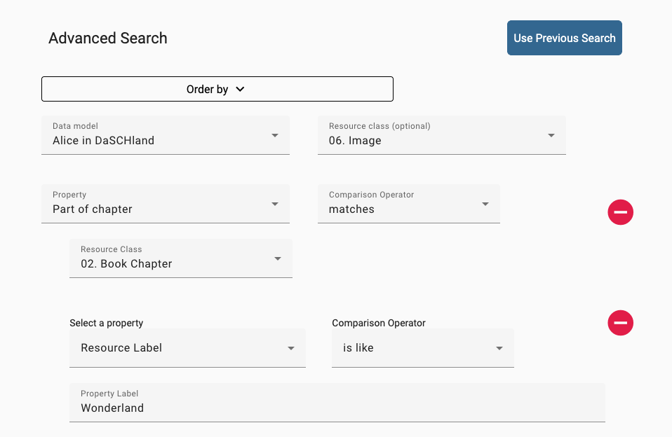
Result: 53 Images, all belonging to the story “Alice in Wonderland”. All images that belong to the other story and all alternative images were ignored.

